Trustee Application, Area 3

Application Instructions and Requirements
Please complete this application and submit it with all required materials. All application materials must be received by the Board Office no later than Friday, February 6, 2026, at 5:00 p.m.

Eligibility Requirements (Trustee Area 3)
Applicants must:
- Reside in Trustee Area 3 of the Coast Community College District, which includes Huntington Beach and portions of Westminster
- Be at least 18 years of age
- Be a registered voter
- Not be disqualified from holding civil office under the Constitution or laws of the State of California
- Not be employed by the Coast Community College District while serving on the Board
Before completing and submitting this application, applicants must verify residency by contacting the Orange County Registrar of Voters at 714-567-7586.
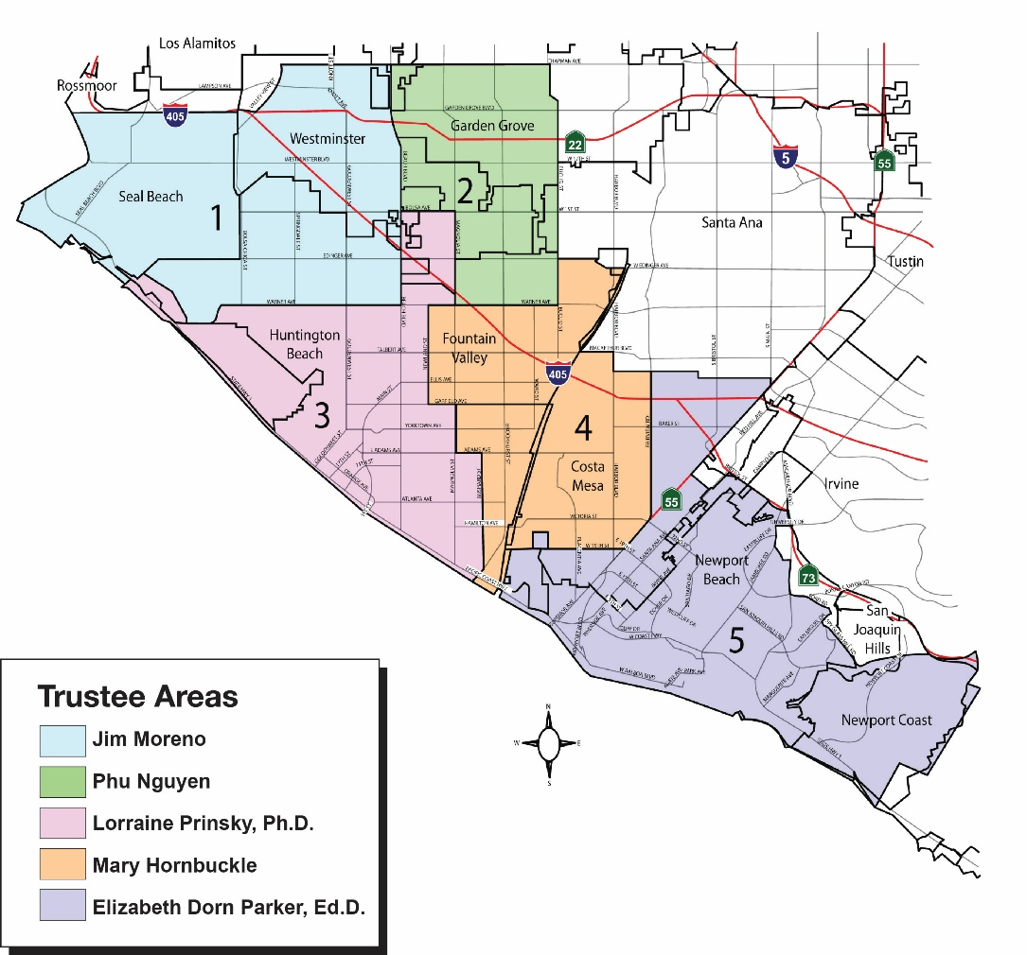

Submission Requirements
Applicants must submit:
- A completed application form
- A Letter of Interest addressed to the Board Secretary, Ricky Goetz
- A Resume

Submission Method
Completed applications and required materials may be:
- Mailed to:
Coast Community College District
Board Office
c/o Ricky Goetz
1370 Adams Avenue
Costa Mesa, CA 92626
- Personally delivered to the Board Office at the address above
- Emailed to: boardoftrustees@cccd.edu
Reminder: All application materials must be received by the Board Office no later than Friday, February 6, 2026, at 5:00 p.m.

Interviews
Interviews will be held on Monday, February 23, 2026 at the Coast Community College District.

Questions
For questions regarding this application, please contact:
Ricky Goetz
Board Secretary
boardoftrustees@cccd.edu
714-438-4610

Contact Information
First Name: Click or tap here to enter text.
Last Name: Click or tap here to enter text.
Home Address (must be a street address): Click or tap here to enter text.
Phone: Click or tap here to enter text.
Email: Click or tap here to enter text.
Occupation: Click or tap here to enter text.
Company Name: Click or tap here to enter text.
Business Address: Click or tap here to enter text.
Business Phone: Click or tap here to enter text.

Application Questions
Please answer the following questions. It is important that each question be answered.
- How many years have you resided in the Coast Community College District?
Click or tap here to enter text.
- Have you worked on any public school or community college committees or participated in any school or college activities recently? If so, list below:
Click or tap here to enter text.
- Please describe other community activities in which you have engaged.
Click or tap here to enter text.
- Why would you like to be a member of the Coast Community College District Board of Trustees?
Click or tap here to enter text.
- What do you see as the basic purpose of the California community colleges?
Click or tap here to enter text.
- What, in your opinion, is the role of the Board of Trustees in a community college district?
Click or tap here to enter text.
- What should be the relationship between the Board members and the administration in the handling of college concerns?
Click or tap here to enter text.
- What do you see as the strengths of the Coast Community College District?
Click or tap here to enter text.
- What do you see as the areas most needing improvement in the Coast Community College District?
Click or tap here to enter text.
- Do you or does anyone in your immediate family or your employer contract with or do business with the district? If yes, please state all pertinent facts.
Click or tap here to enter text.
- Are you related to a current employee of the District? If yes, please provide the name of employee and your relationship.
Click or tap here to enter text.

Supporting Documents
Please include the following documents with your submission. Both items are required for a complete application. Check off each document you are including:
☐ Letter of Interest addressed to the Board Secretary, Ricky Goetz
☐ Resume
Incomplete submissions may not be considered.

References
Please list the names, telephone numbers, and email addresses of three persons who can provide information on your qualifications for service as a trustee.
- Reference 1
  - Name: Click or tap here to enter text.
  - Phone: Click or tap here to enter text.
  - Email: Click or tap here to enter text.
- Reference 2
  - Name: Click or tap here to enter text.
  - Phone: Click or tap here to enter text.
  - Email: Click or tap here to enter text.
- Reference 3
  - Name: Click or tap here to enter text.
  - Phone: Click or tap here to enter text.
  - Email: Click or tap here to enter text.
All three references are required for a complete application.

Eligibility Confirmation
I certify that I meet all eligibility requirements to serve as a member of the board. I understand that I may not serve as a member of the board while an employee of the District. To be eligible, I affirm that I:
- am at least 18 years old;
- am a resident of Trustee Area 3;
- am a registered voter; and
- am not disqualified from holding civil office by the Constitution or any law of the state.

Date: Click or tap to enter a date.
Signature:

